San Diego World Affairs Council and UCSD's Institute of the Americas
Directions and Parking Information:

Institute of the Americas
UCSD Campus
10111 N. Torrey Pines Road
La Jolla, CA 92037
Room: Hojel Hall of the Americas Auditorium

Please Park in the Pangea Parking Structure (ROOF LEVEL). To walk to the Institute, from Pangea Drive, walk uphill (east) on Thurgood Marshall Lane for one block, and turn left onto International Lane. The Institute's complex is located where International Lane ends. (4-minute walk)

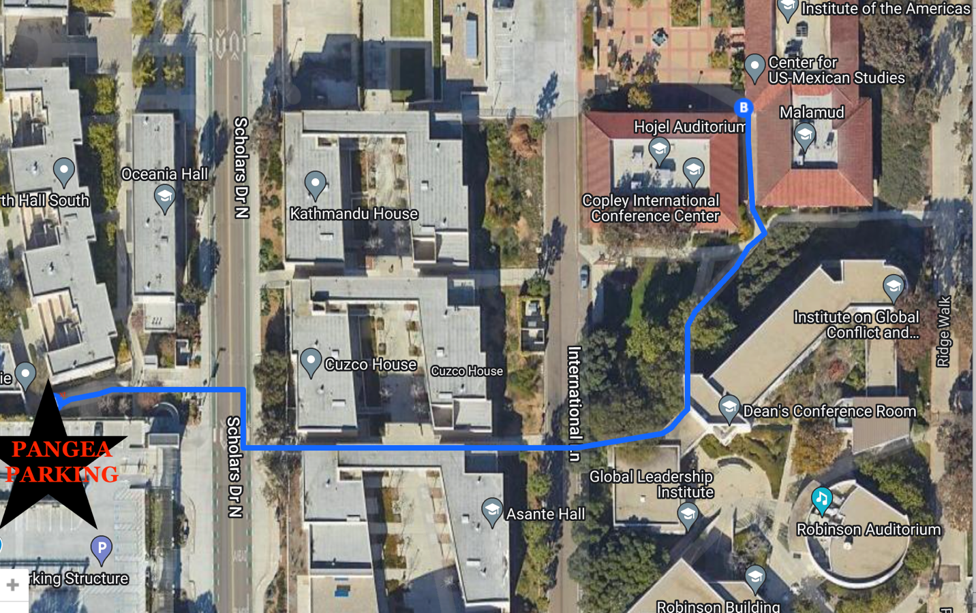

Please Park on the Roof level at the corner of Pangea Drive and Scholars Drive.

Please purchase a short-term permit at the self-service machine once parked: Located in the front and back (right-hand side) of the Pangea Parking structure (street-level) and roof level at the corner of Pangea Drive and Scholars Drive. Note that the booths are always.
Unmanned.

